CHAPTER 2
Statistical Experiments and Significance Testing
- Whenever you see references to statistical significance, t-tests, or p-values, it is typically in the context of the classical statistical inference “pipeline” (see Figure). This process starts with a hypothesis (“drug A is better than the existing standard drug,” or “price A is more profitable than the existing price B”). An experiment (it might be an A/B test) is designed to test the hypothesis—designed in such a way that it hopefully will deliver conclusive results. The data is collected and analyzed, and then a conclusion is drawn. The term inference reflects the intention to apply the experiment results, which involve a limited set of data, to a larger process or
population.
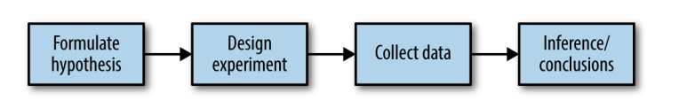

> A/B Testing
- A sample is a subset of data from a larger data set; statisticians call this larger data set the population.
- Random sampling is a process in which each available member of the population being sampled has an equal chance of being chosen for the sample at each draw. The sample that results is called a simple random sample.

